Sophia Anderson
1/13/2026
Bumble Bee Sensor Software Setup SOP

This document outlines the steps required to install, configure, and verify the scripts and software libraries necessary for operating the Bumble Bee sensor. Following this procedure ensures reliable sensor initialization and consistent behavior during testing and development activities.

- Verify Required Hardware and Software Environment
Before installing or running any scripts, confirm that the required hardware and software prerequisites are available and correctly configured.
This typically includes:
- Bumble Bee sensor hardware connected and powered correctly
- Pico Pi W (or target controller) identified and accessible
- Correct firmware or MicroPython version installed
- Development machine connected and able to communicate with the device (USB/Bluetooth, as applicable)
The YouTube link below should help you with setting up the Raspberry Pi Pico W.
Note: I used MicroPython (not CircuitPython)
https://www.youtube.com/watch?v=I7p-vmC8XfU

- Download Required Libraries
Required Libraries
This section lists the software libraries required for proper operation of the Bumble Bee sensor scripts. All listed libraries must be installed and available in the target environment before running or modifying any Bumble Bee sensor scripts.
Library Overview
The Bumble Bee sensor scripts rely on a combination of core MicroPython libraries and custom or third-party modules to support sensor communication, data handling, and system control.
Required Libraries
Ensure the following libraries are present on the Pico Pi W or in the project directory:
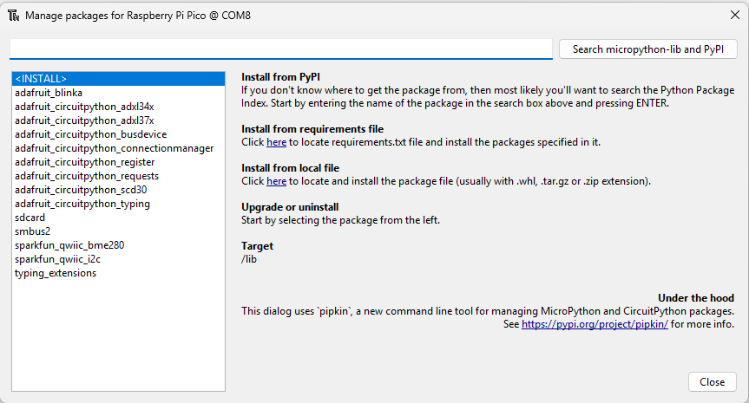
Library Location
Libraries should be placed in the following location:
- On-device library directory (e.g., /lib on the Pico Pi W)
Verification
- After installation, verify that all required libraries can be successfully imported without errors before proceeding to script execution.

- Script and Library Deployment
This section describes the process for extracting the Bumble Bee sensor script package and transferring all required files to the Pico Pi W.
Extract Script Package
- Locate the provided Bumble Bee sensor zipped folder.
- Extract the contents of the zip file to a known location on the host computer.
Note: Ensure the folder structure remains unchanged after extraction.
Note: You will need to use RTC_Set.py before running rtc.py, this is so you set up the real time clock correctly.
Transfer Files to Pico Pi W
- Open the extracted folder and verify that it contains:
  - Main Bumble Bee sensor scripts
  - A lib directory containing required libraries
- Connect to the Pico Pi W using the appropriate file transfer method (e.g., USB, IDE file browser, or Bluetooth transfer).
- Copy all files and folders from the extracted directory to the Pico Pi W, including:
  - All root-level script files
  - The entire lib folder and its contents
Important: Do not omit or rename files. The lib folder must be transferred in full for the scripts to function correctly.
Verify File Placement
After transfer, confirm that:
- Script files are visible on the Pico Pi W
- The lib directory exists and contains all required library files
- Folder structure matches the extracted package
It should look like the pictures below.
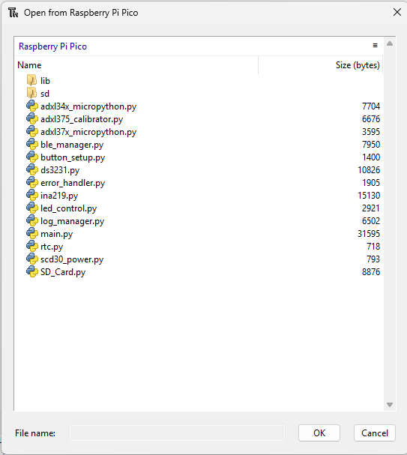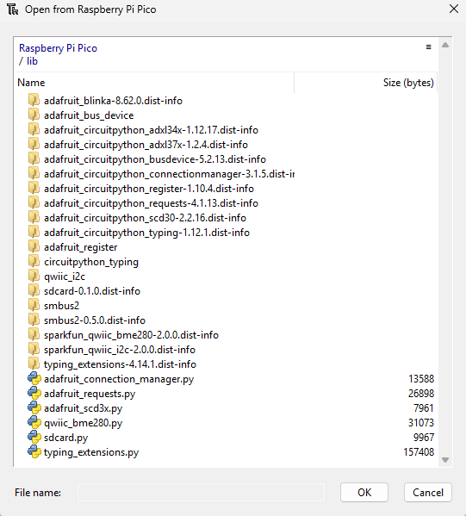

- Sensor Initialization and Script Execution Order
This section defines the required sequence for initializing the Bumble Bee sensor system. All scripts must be present on the Pico Pi W (see Figure X) and executed in the order outlined below to ensure proper sensor startup and system stability.
Pre-Execution Check
Before running any scripts, verify that:
- All files shown in Figure X are present on the Pico Pi W
- The lib directory exists and contains all required libraries
- No files are missing or renamed
Initialization Sequence
Run the following scripts in order:
- button_setup.py
Initializes button inputs and verifies GPIO configuration.
- led_control.py
Configures LED indicators used for system status and feedback.
- RTC_Set.py/rtc.py / ds3231.py
Initializes the real-time clock and verifies timekeeping functionality.
- ina219.py
Initializes power and current monitoring.
- scd30_power.py
Controls power delivery and startup for the SCD30 sensor.
- adxl34x_micropython.py / adxl37x_micropython.py
Initializes accelerometer sensors and verifies communication.
- adxl375_calibrator.py (if calibration is required)
Performs sensor calibration routines.
- SD_Card.py
Initializes SD card storage and verifies read/write access.
- log_manager.py
Sets up logging structure and file handling.
- ble_manager.py
Initializes Bluetooth communication services.
- main.py
Executes the primary application logic and begins normal system operation.
Important: Allow each script to complete successfully before proceeding to the next. Do not skip steps unless explicitly instructed.
Execution Method
Scripts may be run using the approved development environment (e.g., IDE run command or REPL execution). Once initialization is complete, main.py may be configured to run automatically on startup if required. I prefer to use the green arrow (Run current Script (F5)) and press the stop button (Stop/Restart backend (Ctrl + F2)).

Completion
Upon successful completion of the steps outlined in this SOP, the Bumble Bee sensor software environment will be fully configured and initialized. All required scripts and libraries will be properly deployed to the Pico Pi W, and sensors will be initialized in the correct order to support normal operation, testing, and data collection.
If errors are encountered during setup or initialization, verify that all required files are present, libraries are correctly installed, and scripts are executed in the specified sequence before proceeding.

